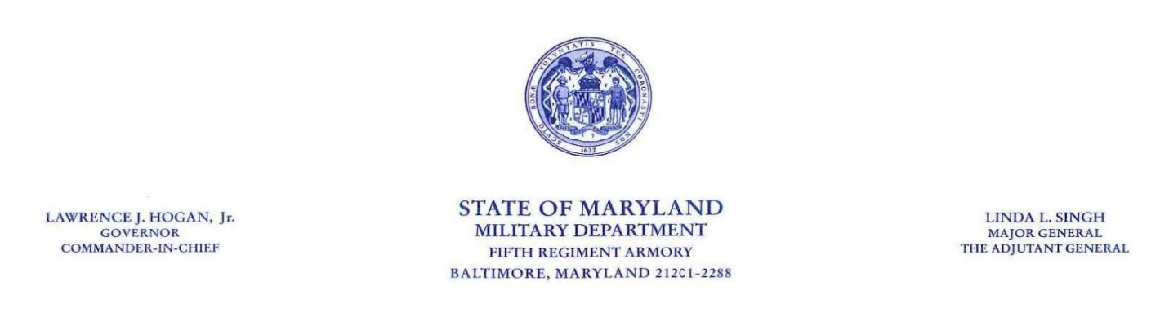

Date: _______________

I would like to request a waiver for the July 2017 PEP cycle for ___________________________ due to the following reason: (Name & W#)
______ Currently on Military Orders
______ Currently on FMLA Leave or other Medical Leave
______ Started with our agency after December 1, 2016
______ Other __________________________________________________________________________________________________________________________________________________________________________

Waiver requested by: __________________________
Printed Name of Supervisor
__________________________
Signature of Supervisor

Approved by: _________________________ Denied by: _______________________
DMIL Appointing Authority DMIL Appointing Authority

