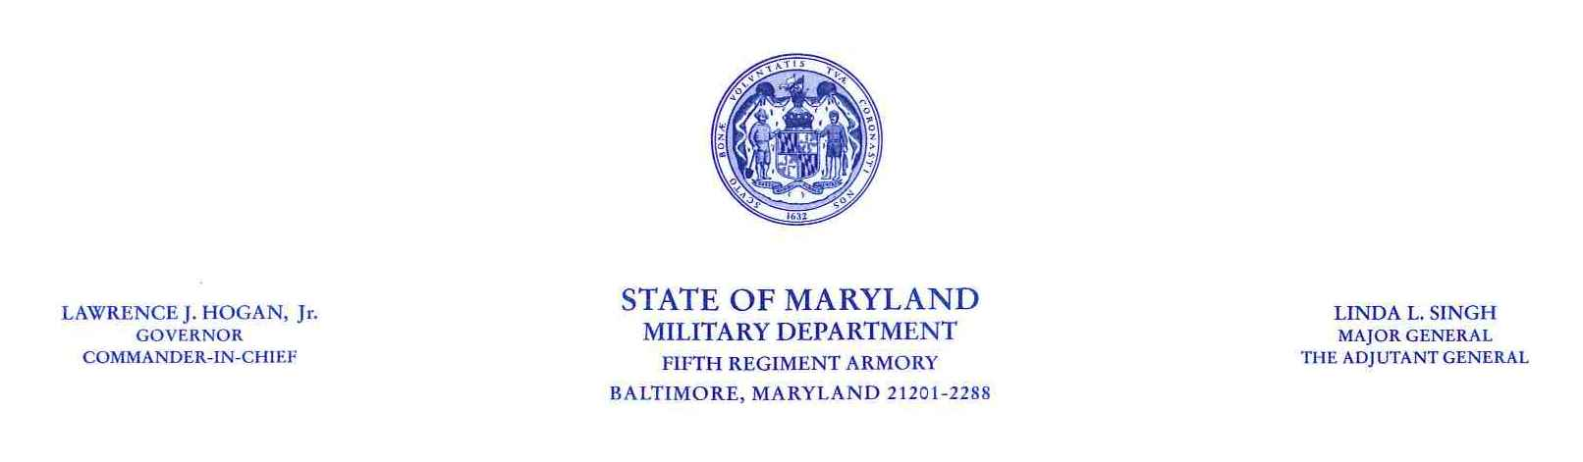

To: _________________________ Date: _____________
_{Employee’s Name}

From: _______________________
Supervisor’s Name

SUBJECT: FY 2017 Mid-Cycle Evaluation

This memo is to confirm that our Mid-Cycle evaluation meeting occurred on _____________.

As we discussed during this meeting your overall performance for this rating period was *_____________________. You exhibited **________________ job performance, ***____________________ the required and expected results for your position.

Your contributions to our program and the Military Department are appreciated.
This employee’s MS-22 is current? ____Yes ____ No

Supervisor Signature: ______________________________________ Date: __________

Employee Signature: _______________________________________ Date: __________
Signature acknowledges receipt of this memo and does not imply agreement or disagreement

cc: Employee
Manager File
HR File

This format should only be used for Mid-Cycle PEP’s with an overall rating of Satisfactory or Outstanding.
For Mid-Cycle PEP’s with an overall rating of Unsatisfactory please contact SPO and use the End of Cycle form.

Notes *
*) Enter “Satisfactory” or “Outstanding” here.
**) Enter “good” if rating was satisfactory or “outstanding” if rating was outstanding.
***) Enter “meeting” if rating was satisfactory or “exceeding” if rating was outstanding.

